ITSP 2018  **TEAM ID- 31**

**Project Documentation TEAM NAME- C.O.B.R.A.**

The Snake Bot

horizontal line

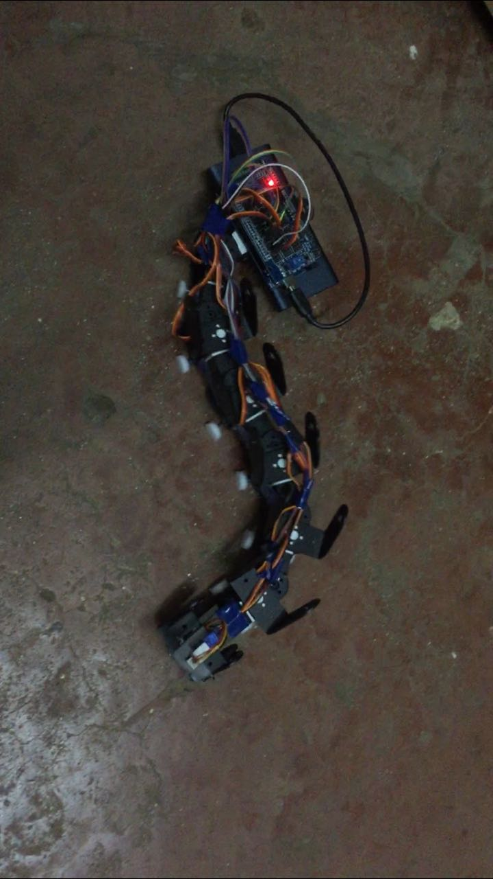

# 

# Description Of The Bot

The snake bot is an autonomous bot which moves due to its body convolutions just like an original snake does. Though it does have wheels, they are not motorised and their only purpose is to ensure that the friction faced by the bot along its length is less than that perpendicular to it (again just like it is in an original snake).The snake contains 6 segments actuated by servo motors and joined with metal brackets. The servos are controlled by an Arduino Mega and powered by a power bank(10.5 V) and a 7.4 V Lithium ion battery.

## 

# Making The Bot

1. First task was to understand the algorithm that makes the bot move.
2. Understanding the connections was pretty simple:- arduino connected to and giving directions to each of the servos
3. For the structural part we had to think a little bit as we had to look for some clean and sturdy way in which the different servos would be connected to each other and the arduino while in motion and still allowing controlled rotation between them.Each of the 6 segments consists of a servo motor, a C-bracket and a set of Lego wheels. After all 6 segments are connected, head and tail sections need to be added in order to accommodate the Arduino and the power bank.
4. All the servos are connected to various pins of the arduino sensor shield, which gives instructions to each servo to turn in such a way so as to develop a sine wave along the body of the bot.
5. The IR distance sensor (range 2-80 cm) is mounted on the head of the bot. It gives distance analog reading as the output which is then fed into the if-else loop and hence, the bot moves accordingly.
6. We said the distance analog reading tolerance as 450 i.e. if the distance analog reading sensed by the sensor is less than 450, then the bot will move forward and otherwise.
7. After every modulation, the IR sensor would feed the reading, leading to the smooth moment of the bot.

# Timeline

### WEEK 1

1. Procured the basic parts like arduino, jumper wires etc. .
2. Ordered the servos online.
3. Worked on the algorithm and code.
4. Started connecting the servos with Double sided tape and observed how they worked with each other when connected together to the arduino.
5. Attached the wheels using empty pen refills.
6. Figured out the best combination of arduino pins that would synchronise all the servos efficiently.

### WEEK 2

1. Studied about the technicalities of IR distance sensor.
2. Mounted the IR sensor on the head of bot with the help of a micro servo and double sided tape.
3. Used serial print to find out the required distance tolerance.
4. Placed the arduino and the power bank at the back of bot.
5. Organised the jumper wires network neatly.
6. Tested the bot several times.
7. Completed the project.

# Challenges Faced

1. Well, the biggest challenge was getting the double shaft servos and the c brackets as they are not available at any retail store in mumbai.
2. We had to make a lot of efforts to find the appropriate power source because we needed a power source of approx. 10 volts that would power both the servos and the arduino.
3. Perfecting the left and right turns was a big challenge as we had to set the appropriate values of left offset and right offset.
4. The IR sensor was quite sensitive, it gave a varied range of readings for almost the same distance. So we had to make changes in the code, we took the weighted mean of hundred values, hence minimizing the reading error.

# Reference Links

1. <https://www.youtube.com/watch?v=3YH25vspiJo>
2. <http://www.sharp-world.com/products/device/lineup/data/pdf/datasheet/gp2y0a21yk_e.pdf>

# Materials used

1. Arduino mega 2560 - 944/-
2. Sensor shield - 365/-
3. 6 dual shaft servos - 8142/-
4. 8 normal servo C-brackets - 1320/-
5. 6 oblique servo C-brackets - 849/-
6. 2 long servo C-brackets - 354/-
7. 16 lego wheels - 80/-
8. 1 micro servo - 130/-
9. 1 IR distance sensor - 450/-
10. Jumper wires - 300/-
11. 7.4 V Lithium ion battery
12. Mi power bank - Previously arranged
13. Pen refills as wheel axles - TL
14. Double sided tape and adhesive - 50/-

## Youtube video

https://www.youtube.com/watch?v=iB6GeReXNPA&t=14s